**Getting the FW 893 Class Material from GitHub**

Note: This Class Material folder needs to be:

* in a separate folder/RStudio Project from your class work
* treated as a read-only folder (you do not have access to edit my repository)

Creating a new RStudio Project that links to GitHub:

In RStudio click:

File 🡪 New Project… 🡪 Version Control 🡪 Git

* **Repository URL**: https://github.com/QFCatMSU/GGPlot-Class-Material/
* **Project directory name**: can change if you want – but no need to
* 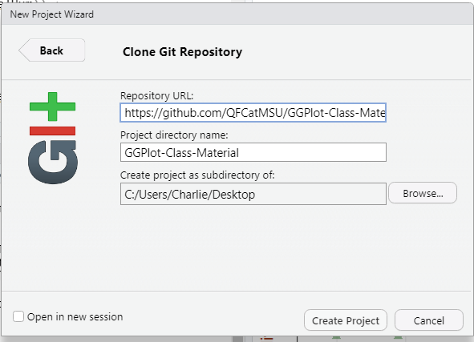**Create project as subdirectory of**: this is your choice

Press to ***Pull*** button (blue down arrow) to get the latest material from the repository: